ATTN: Chief Health Officer

May 15, 2025

Dear <Chief Health Officer>:

This concerns your policyholders who have allergic conditions, including allergic rhinitis, allergic asthma, and allergies to insect stings.
These conditions are serious, and they can be debilitating or even deadly. Fortunately, there is cost-effective treatment that helps many people suffering from these conditions: allergen immunotherapy or “allergy shots.” This treatment is well established and medically necessary.

The American College of Allergy, Asthma & Immunology (ACAAI) has seen an alarming trend of health insurance payers using claims processing criteria, processes and tactics that unreasonably delay or halt payment for medically necessary allergy treatment, even though the treatment is covered under the insured patient’s plan. These practices include a variety of unreasonable or unnecessary documentation requests and auditing procedures.

Allergen immunotherapy is a sequential treatment – spaced, dosed and scheduled specifically for each patient’s allergies. Delaying or stopping treatment is a critically disruptive event in this process.

ACAAI, along with the American Academy of Allergy, Asthma & Immunology and the American Academy of Otolaryngic Allergy, issued guidance on this matter in January of this year. This guidance clearly outlines what are reasonable documentation requests for these medical services, and what are unreasonable requests. The CPT codes pertaining to allergen immunotherapy are: 95165, 95115, and 95117.

In addition to keeping allergy treatments on track, this expert guidance established by our professional societies will help payers to institute a more efficient process as well, as it will avoid the unnecessary, repeated requests for documentation that is extraneous to claim review and approval.

Please ensure that any employee of your company who is responsible for reviewing and/or approving allergy treatment claims is aware of this guidance. If our guidance does not align with your current practices, we request that Cigna Group immediately: 1). cease any unreasonable or onerous documentation requests and auditing practices for these claims; 2). cease any other tactics meant to delay payment; and 3). adopt the criteria and recommendations shared in our guidance document.

As it is extremely important that our request receive prompt attention, please acknowledge receipt of this communication by sending an email to: AdvocacyCouncil@acaai.org

Physician leaders at ACAAI are available to speak with a representative of your group should you have questions or need additional information. To schedule a call or meeting, contact us at AdvocacyCouncil@acaai.org

We thank you on behalf of the patients whose welfare we share in common, and to whom we have all promised this care.

Sincerely,
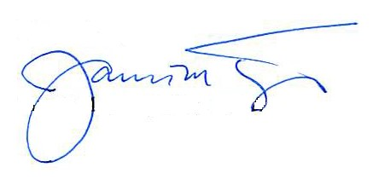
James M. Tracy, DO, FACAAI
President
American College of Allergy, Asthma & Immunology

