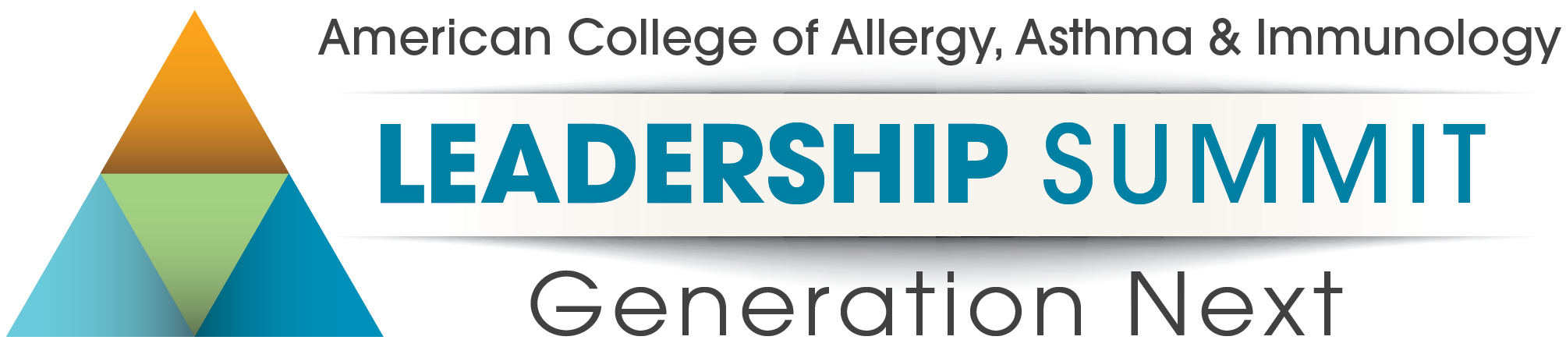

March 26-27, 2022
Hilton Chicago O’Hare
Application

The medical profession is rapidly evolving and allergists want to know how to thrive amidst a changing health care landscape. The College Leadership Summit: Generation Next brings together thinkers and future leaders in allergy/immunology to learn innovative approaches to lead in an ever-changing world. Over the course of 1 ½ days, 20 participants will engage with College leadership and expert faculty in interactive sessions to develop a personalized leadership roadmap with goals, a toolkit of skills, and benchmarks to track their progress.
Applicants must be active members of the College, 45 or younger or in practice 10 years or less. To apply, please complete the application, then save it and email to Katerina Barcal, MPH, Director of Administration, at katerinabarcal@acaai.org by February 4, 2022. All information shared in this application will be kept confidential.

Note: The College Leadership Summit application process is competitive. The ACAAI Member Relations Committee will review all applications to select the 20 participants to attend. The College is looking for participants who come from diverse settings, have varied levels of experience and a strong commitment to the specialty.

 | Personal Information
 | First Name: | Last Name: | Member ID:
 | City: | State: | Zip:
 | Gender: | Race/Ethnicity (optional):
 | Age:
 | Professional History
 | Number of years in practice: | Practice Type: | Are you ABAI certified?
 | Type of membership: Fellow Member Year Joined:
 | Describe your current professional setting (75 words):
 | Leadership Self-Assessment |  |  | RATING
 | On a scale 1-5, please rate your leadership abilities based on your perceived level of competence (with 1 representing areas that need most improvement and 5 representing areas where you possess strong abilities)
 | Communication (influencing people, generating buy-in and consensus, resolving conflict) |  |  | 1 2 3 4 5
 | Advocacy (representing the specialty, engaging in public policy) |  |  | 1 2 3 4 5
 | Team Building (strengthening teams, leading by modeling oneself to others, fostering positive interpersonal relationships) |  |  | 1 2 3 4 5
 | Change Management (problem-solving, facing new challenges, managing times of change) |  |  | 1 2 3 4 5
 | Public Speaking (speaking with presence, interacting with the media, delivering messages with confidence) |  |  | 1 2 3 4 5
 | Innovation (driving growth initiatives, embracing new approaches) |  |  | 1 2 3 4 5
 | Organization (goal setting, benchmarking, planning) |  |  | 1 2 3 4 5
Describe your current professional goals and aspirations in health care (1 to 2 sentences):

Describe any challenges you are currently facing in your current position (100 words):

List three of the biggest strengths that you possess as a leader:
1.
2.
3.

List three areas where you would like to grow as a leader:
1.
2.
3.

Involvement in the College
Are you a current committee member or chair?
If so, which committee(s) do you serve on?
If you were recommended by an existing committee member, board member or past Leadership Summit participant, please list their name below:

