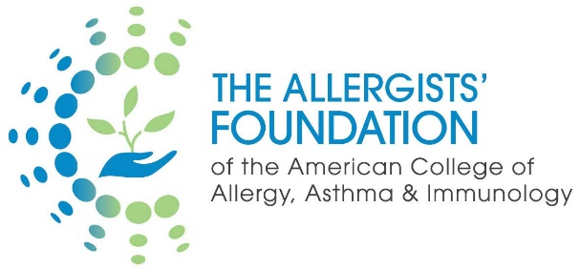 | Community Grant Program

LETTER OF INQUIRY

Project Information
Project title (limited to 30 words)
A brief descriptive title for your project.

Which category of grant are you applying for?

Planning/Exploratory Grant |  | Implementation Grant

Proposed start date
If the grant for the project is approved, when do you anticipate being able to start? (Grants must be started no later than August 1, 2022)

Proposed end date
If the grant for the project is approved, when do you anticipate being able to complete your project? Be sure to include time to complete and submit any grantee reports. Please be realistic, rather than optimistic. (Planning/Exploratory grants must be completed no later than 8/1/2023, and Implementation grants can have up to 8/1/2024 if requested)

Amount Requested (limited to 150 words)
Provide a brief justification for the requested funding and what expenses it will cover. (up to $10K for a Planning Exploratory Grant; up to $25,000 for an Implementation Grant)

Narrative
What challenges faced by community practicing allergists does your project address? (limited to 300 words)

Why are you the right person, team, or organization to address this problem? (300 words)
Brief description of past experience, key partnerships, and what you've done to address this problem so far. (Do not paste in CV, this should be included as a separate attachment.)

Describe the project design. (limited to 500 words)
Brief description of the project design and methodology and how it will address the problem. (Please save info on goals, objectives, and outcomes for the next question below.)

What are the goals, objectives and outcomes for the project? (limited to 500 words)
Please briefly describe 1) The overall broad GOALS for your project; 2) The realistic, specific, concrete OBJECTIVES you plan to accomplish to achieve the goals; and 3) Specific, measurable OUTCOMES (effects) you expect to come out of the project.

CV/Resume Attachment
Please attach your CV/Resume (NIH format).

Attestation Form

Please answer each question below by placing a check mark next to your answer.

 | Yes | No
Do you have another source of funding for the proposed project?
I am a 1st year Fellow-in-Training at an accredited Allergy/Immunology program and member of the College and the Training Program Director for my institution is a member of the College.
I am a 2nd year Fellow-in-Training at an accredited Allergy/Immunology program and member of the College and the Training Program Director for my institution is a member of the College.
I am a practicing allergist and member of the College with less than 10 years in clinical practice.
I am a practicing allergist and member of the College with more than 10 years in clinical practice.
 | Agree
If this is a Planning/Exploratory Grant, I understand and agree that all research and reporting will be completed within a one-year time frame.
The funds from this grant will not be used for salary support for the primary investigator.
Research projects involving human subjects will require IRB approval.
An abstract for presentation at the ACAAI Annual Scientific Meeting will be submitted.
Annals of Allergy, Asthma and Immunology will be given first right of refusal to publish the findings.
A progress report (every 3 months of the project start date) will be submitted.
A final report (within 3 months of completion) will be submitted.

Signature |  | Date
Printed Name

Fellow-in-Training Applicants Only: Oversight of the project by the Training Program Director is required. By signing below, the Training Program Director acknowledges they support the project and are willing to serve as the principal investigator of record.

Signature of Training Program Director |  | Date
Printed Name

